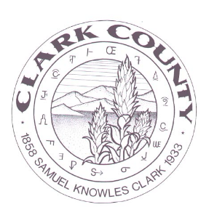
2024 Schedule of Regular Commissioner Meeting
January 8, 2024
February 12, 2024
March 11, 2024
April 8, 2024
May 13, 2024
June 10, 2024
July 8, 2024
August 12, 2024
September 9, 2024
October 14, 2024
November 12, 2024 (Tuesday)
December 9, 2024

All meetings will be held in the Commissioners’ Chambers at 224 W. Main Street in Dubois, ID 83423 unless otherwise noted. Special and Emergency meetings will be scheduled as needed and notices will be posted online and in the Courthouse. Any individual wishing to be added to the agenda should contact the Clerk at least by the Wednesday before the meeting as agendas will be finalized at least 5 days prior to the meeting. The clerk can be reached at 208-374-5304 or via email at sstewart@co.clark.id,us . /s/ Stephenie Stewart, Clark County Clerk.

