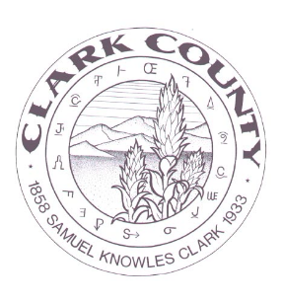
2023 Schedule of Regular Commissioner Meeting
January 9
February 13
March 13
April 10
May 8
June 12
July 10
August 14
September 11
October 9
November 13
December 11

All meetings will be held in the Commissioners’ Chambers at 224 W. Main Street in Dubois, ID 83423 unless otherwise noted. Special and Emergency meetings will be scheduled as needed and notices will be posted online and in the courthouse. Any individual wishing to be added to the agenda should contact the clerk at least by the Wednesday before the meeting as agendas will be finalized at least 5 days prior to the meeting. The clerk can be reached at 208-374-5304 or via email at cmessick@co.clark.id.us . /s/ Camille Messick, Clark County Clerk.

